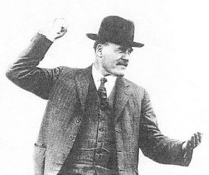 | Birth of the Lang Plan  Jack Lang
During the weekend in Canberra after listening to two days of fruitless argument, I decided that the time had arrived for a showdown. Who were the real enemies of the Australian people? I was not prepared to load the blame on to the workers. They were under attack all the time. They were being blamed for the depression. Their wages were said to be too high.
Theodore and Scullin were hedging. They were not prepared to face up to Labor policy. On the one hand they were afraid of the bankers, and on the other hand did not want to antagonise the trade union movement. They were trying their hand at tight-rope walking. But their umbrellas were already exposed to the rim. The usurers were certain to win.
I always believed in the old principle that the best form of defence is attack. For six months the bankers had been on the attack. Theodore was no more anxious for a showdown than Lyons. I realised that if someone did not put up a fight we would all go down, and with us the Australian economy.
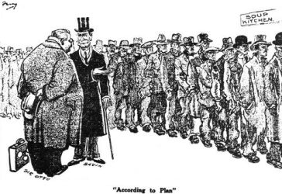
I also realised that if I took the stand, which was the only possible one for a self-respecting Australian to take, it would raise a political hurricane. The propaganda that Australians must make further sacrifices to the Moloch of Mammon had been sown so deeply that anyone challenging the idea was certain to be pilloried. Still, it had never been my habit to indulge in speculation regarding the consequences of my political actions. If I believed that a certain course of action was right, then it was not for me to trouble about the consequences. After all, I had only one political life to live. The people had trusted me, and I was not prepared to betray that trust.
Sir Otto Niemeyer had said that the trouble with Australia was that the workers were enjoying a champagne standard of living on a small beer income. I had countered that his aim was to reduce it to the rice bowl standard. Now I felt that the onus was fairly upon me to show that there was an alternative way.
As soon as the conference assembled on Monday, February 9th, I took the floor and said that desultory talk would get us nowhere. I said that I not only proposed to place suggestions on the table, but would also indicate what the Government of New South Wales proposed to do. Scullin and Theodore looked stunned. They hadn't a clue as to what was in my mind. The other Premiers were just waiting to pounce.
The people were confused and bewildered. One day they were told that there was to be deflation. Next day that a small dose of inflation was needed. The word repudiation was bandied around. Everyone agreed that all that was needed was a return of confidence. Yet at no stage was it known what Government policy was to be. The Governments themselves did not know. How, then, could the people? I suggested that a policy covering five years was needed. At that, Mr. Barnes, of Queensland, suggested that the term should be three years.
I agreed that we should not quarrel over the time period. We had all agreed that expenditure had to be reduced or we should all go bankrupt. Again I was not going to raise any dispute. But when it came to the actual reductions, two principal items emerged - wages and interest. Of these, interest was the greater.
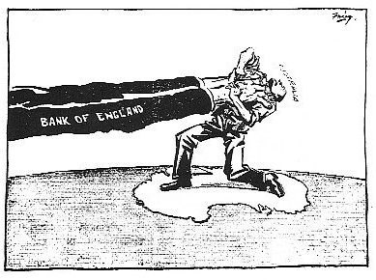
Under the Niemeyer plan, interest was to be sacrosanct. I countered that wage reductions would not do the job. In New South Wales civil servants had been cut 8½ per cent. by the Bavin Government. If they were reduced a further 10 per cent., we would save only £1 million. That would mean the State deficit of £8 millions would fall to £7 millions.
Even if we reduced wages by half we could not bridge the gap. If for the following six months we paid no salaries or wages to police, asylum attendants, teachers and other public servants, we would still be in the red.
If we dismissed every railway employee the position would only be worse. There would be no revenue to pay the interest bill. We could not even feed the workless. Every Premier was in precisely the same position.
The other item was interest. For my Government alone, it amounted to £8 millions, to which had recently been added an additional £1½ millions exchange. It was a burden that we could not and should not be asked to carry in such abnormal times. Much of it was due to the war. The loans had been floated when prices were high, and had to be repaid at deflated prices. Where two shiploads of wool were required to pay a bondholder in 1929, four shiploads were needed in 1931. The debts had doubled in terms of goods, although still nominally the same amount.
I proposed that we should fund our debt as Britain had funded her war debt to America. Firstly, America had agreed to suspend all interest payments for three years. Then Mr. Baldwin had persuaded the Americans to reduce interest charges from 5 per cent. to 3 per cent., rising to 3½ per cent., with payments spread over 62 years. Even then there were critics in London who suggested that not more than 2 ½ per cent. should have been offered. Belgium, Italy and France all negotiated similar arrangements, Italy paying no interest at all for five years.
I proposed that we should issue a declaration that we had decided upon a funding of the overseas debt, both principal and interest, along the same lines as those accepted by the United States. The causes of our troubles were precisely the same as those which had compelled Britain to compound with her overseas creditors. If we could do as she had done on the same conditions, our troubles, internationally, would be over.
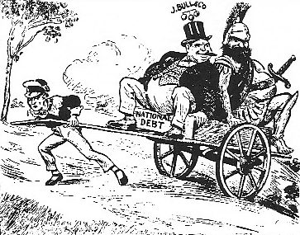
Many Australian unemployed had soldiered in France. They had made sacrifices on the battlefield. Now they were repeating them in Australia. Why should they face another ten years of misery and privation? There would have been no hardship and suffering had Australia not gone to Britain's aid. Should the men who had done the fighting now go without the necessities of life in order that the international money ring should have its pound of flesh? I suggested that the British investor should be paid back no more than he lent in terms of goods. Otherwise we were penalising Australia for having gone to war. It would mean that of all countries on the Allied side, Australia would be singled out for a form of reparations akin to that being exacted from Germany through the Versailles Peace Treaty. We were being treated like a vanquished foe, instead of an ally.
If we could cut our interest bill in half we would have enough to find jobs for our unemployed, and enough to save the farmers from bankruptcy. So that was the first step - adjustment of our overseas commitments.
The second point concerned internal interest payments. Rent and interest had become the greatest factors in maintaining the costs of production, about which everyone was complaining. Even the banks had admitted that interest charged was too high. The only reason they had given for not reducing their charges was that the government rate was too high. I proposed that we should cut government interest payments by half.
Then, if the bankers were playing the game, the interest bill for every farm, home and business would be cut in two automatically. It was the only way to tackle the problem. An employer could sack men and close down his factory, but his interest on his overdraft did not stop. Whether his factory was working to capacity, or whether every machine was idle, the interest charge was the same. The bank had absolute priority. Interest had become an intolerable burden. Governments, businessmen, farmers, home owners and workers were all being crushed.
Thirdly, I said that we had to do something about our currency problem. Australia had not gone back to the gold standard in 1925 because she wanted it. Britain had dictated the move. We were not consulted. We were never in the picture. The return to gold had proved the greatest blunder of the Bank of England. Agrarian countries suffered most.
The artificial movement of gold dominated price levels. Costs depended on the amount of gold taken out of the ground, or hoarded in a central bank vault, instead of being based on the value of labor and other costs. Even the price of bread was determined by the scarcity or plentiful supply of gold. Yet at every test the gold standard had collapsed. Mr. McKenna, of the Midland Bank, had admitted that it had failed again. Mr. J. F. Darling was proposing a Super-Empire Bank with a bi-metallic of gold and silver.
I proposed that the Australian paper pound, based on the value of goods produced - our primary and our secondary production - should be substituted for the out-of-date gold standard. At that stage it was rank banking heresy.
The danger was that we would be ground by the banks and great financial institutions between the upper millstone of usury and the lower millstone of financial speculation. In conclusion, I submitted formally my proposals.
- That the Government of Australia decide to pay no further interest to British bondholders until Britain has dealt with the Australian overseas debt in the same manner as Britain settled her own debt with America.
- That in Australia interest on all government borrowings be reduced to 3 per cent.
- That immediate steps be taken by the Commonwealth Government to abandon the gold standard of currency, and set up in its place a currency based on the wealth of Australia, to be termed the Goods Standard.
That was the Lang Plan. It was both positive and challenging. It was not to be left long in doubt as to the way in which it was to be received.
An experienced politician learns to watch his audience. He has to be sensitive to its reactions. I had learned that it was essential to state every proposition in the simplest possible terms. That applied to a meeting of Premiers and experts just as much as it applied to a street meeting.
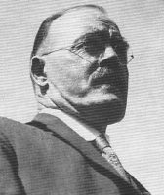
So as I unfolded the Lang Plan I kept my eyes moving around the table. To say the impact was a shock would be an understatement. If someone had let loose a death adder in the room it could not have caused greater consternation.
I had fully expected the Nationalist Premiers to get steamed up over my proposition. It struck directly against all the things which they regarded as sacred. I was proposing to reduce interest payments by legislation. To them that was rank heresy.
But my attention was principally rivetted on Scullin and Theodore. Scullin paled perceptibly. That was the day he became His Grey Eminence as he was called later. He realised that I had deliberately offered him the choice of doing something for the unemployed and sticking to the wage earners, or siding with the banks and the bondholders. That was precisely the decision he had no stomach to reach.
Theodore, on the other hand, was bland. He fully realised that he was in the rat trap. But his immediate reaction was that I had euchred his all too nebulous plan of a Fiduciary Issue. He was already thinking ahead for the next move.
Sir James Mitchell, of West Australia, was the first to speak. He just about exploded.
"I desire to dissociate myself from every word and every sentiment uttered by Mr. Lang. Australia would be discredited in the eyes of the world. It is repudiation. If a speech, similar to that of Mr. Lang, were made by a British Minister, there would be disaster. There is not one word uttered by Mr. Lang with which I would agree. I know that the rate of interest is far too high, but we have agreed to pay it. We must pay it."
At least there was no doubt as to where Sir James stood. His simple idea was to reduce government spending by £15 million. He wanted reductions in what he called the "free services." They included war pensions, age and invalid pensions, education, hospital services, the police and penal services. He didn't specify how we were going to cut down on any of them - least of all the penal services. Still, that was his only way - with hands off interest. He was quite confident that the high rate of exchange would not last long. To him repudiation was a real live bogey. So he shied away from the Lang Plan in sheer horror.
Theodore was next. He would not go so far as Sir James and say he disagreed with every word I had uttered. In fact, he believed my diagnosis of Australia's troubles was an accurate explanation of the position. Interest was the real problem. Its burden became heavier the more that prices fell. He even agreed that if they followed my suggestion and cut interest payments by half, vast financial resources would be released to help industry, the governments, and the unemployed.
He admitted that Britain had scaled down her payments to the United States on her war debts. He said that Mr. Scullin was taking up the question of similar treatment for Australia's war debt with the British Chancellor, Mr. Snowden. But it only represented £82 million.
But when he came to the big hurdle of the private bondholders, Theodore said he would not be a party to forcing them to accept less than the bonds provided. That would be repudiation.
That then was to be the rock on which the Labor Party was to be split. He still believed that he could do a deal with the bankers on the short-term debt. He was full of optimism. He was going to see Sir Robert Gibson himself.
But he would not interfere with the interest paid to the private bondholders under any circumstances. With regard to the gold standard, he told us "Frankly facing that position, we have to admit between ourselves that the gold standard has already been abandoned in Australia. Not one of us would say that the Australian notes in circulation could, or would, be redeemed in gold." That statement was typical of Theodore. Why should such an admission be kept confidential? He simply didn't trust the Australian people.
With regard to my proposal to legislate for a reduction of interest, Theodore said that if New South Wales did that, under the Loan Council Agreement, the Commonwealth would have to make up the difference. The banks would then refuse to give New South Wales any more accommodation. Theodore was already hinting at a Commonwealth-bankers' alliance against my government. He said I had taken the first step towards the inevitable smash. He agreed with me that the first duty was to feed the citizens. A quarter of a million were workless and dependent on the worst form of charity. Even that was not sufficient to persuade him to take the bold step that would provide immediate relief.
Ned Hogan of Victoria read out the decisions of the Melbourne Agreement reached at the Niemeyer Conference. He would have none of my plan. It was straight out repudiation. Not that he didn't think interest should be reduced at such a time. Oh no. He suggested that the Commonwealth should take over taxation, and tax interest at its source. Just why that would be different to my proposal, he didn't say.
Scullin said Theodore had spoken for his government. He agreed with what I had said about the difficulties. No government could balance its budget simply by reducing wages and salaries.
Scullin said that when he arrived in England, there had been newspaper posters and front page stories that the Labor Council in Sydney had proposed the repudiation of our war debts.
"I was able to allay the uneasiness by pointing out that the resolution did not represent any responsible body of opinion in Australia; that it emanated from a gathering of individuals who spoke only for themselves," said Scullin, the erstwhile supporter of Sinn Fein, who was much more sensitive to what they were thinking in Whitehall, than what they might be thinking in Richmond, Victoria. He agreed that we had obligations to our own flesh and blood in Australia. But we also had obligations to the bondholders overseas. He agreed that we had the right to obtain the same treatment on our war debts as Britain was herself obtaining. In England there had been the suggestion that Britain had erred in not sticking out for better terms. He had said that if that were so, then Australia had even a better case. But there must be no talk of repudiation. They must aim to restore confidence. Like Theodore, Scullin had baulked at the only fence that could bring him to both political and national safety.
Mr. Moore, the National Premier of Queensland, said my proposal was unthinkable. There must be more sacrifices. Wages must be cut again. Australia had had depressions before and they had all disappeared with the operation of natural conditions.
Lionel Hill, the South Australian Labor Premier, said that on Friday he had been despondent, on Saturday he had been cheerful, and now on Monday he was despondent again. He agreed that my proposals would be most desirable. But he didn't think they would work. Did Mr. Lang propose to break away from the Financial Agreement.
I replied, "I have no objection at all to that; in fact, I desire it."
Hill said that I could not do that. His government had cut expenditure below bedrock. They could get no lower. They had even cut the education vote. Instead of getting better, things were getting worse. He thought the best idea would be for Mr. Theodore to see the bankers. But he was also against repudiation.
Mr. McPhee, the Nationalist from Tasmania, was also a dissenter from my ideas. He said that Theodore's ideas were vague and nebulous, while mine were repudiation and nothing less.
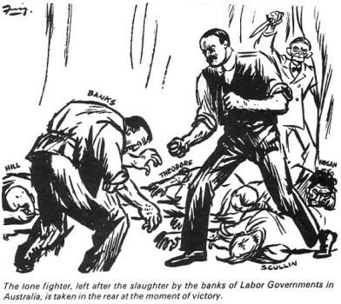
I said that I could see no future in pleading with the banks. As leaders of responsible governments, we should accept our responsibilities. Instead, the others wanted first to go cap in hand to the Commonwealth Bank, and if it agreed to help, then to go cap in hand to the private banks. Yet simply by reducing interest down to 1919 levels, we could all balance our budgets and the bondholders would still be getting the same value for their money in goods as when they lent it.
"You say my plan is partial default. That does not scare me. Nor does it scare me if you call it repudiation. Repudiation is only a word coined for the defence of certain interests. Why not be honest and admit that we could not meet our interest obligations." I suggested that we should tell everyone: "We cannot meet our present obligations. They are impossible. But we can meet half the interest charges without disturbing a penny piece of capital. The whole of your money will remain intact. If you refuse, the alternative is complete default. If we could pay 20s in the £ we would be happy to do so. But we are not going to do it at the expense of the unemployed and the workers.
"The bondholders are like any other mortgagees. They have a mortgage on your sweat. When that sweat does not produce sufficient to meet the interest charge, then you cannot pay it. Every government agrees that we are in that position. Why not face up to it and do something? The other way is cowardice. I am not going to run backwards and forwards to Canberra telling my people that something will be done, when all the time I know nothing is being done."
But no one budged. I had mentioned the unmentionable. For that I was to be treated as a political Ishmael - at war with the rest of the governments. No one wanted to get too close to me. I could see them move away. I was sent to Coventry in Canberra. Yet that did not solve their problems. The next move was up to Theodore. Could he deliver the goods? Having rejected the Lang Plan, could he produce a Theodore Plan that would work?
While I knew that I was going it alone in Canberra, I believed that I would get support from the people. The issue was quickly crystallising. So was the fight looming inside the Labor Movement.

